**Project Design Phase Solution Architecture**

|  |  |
| --- | --- |
| Date | 30 June 2025 |
| Team ID | LTVIP2025TMID37158 |
| Project Name | Transfer Learning-Based Classification of  Poultry Diseases for Enhanced Health  Management |
| Maximum Marks | 4 Marks |

**Solution Architecture:**

This project leverages transfer learning models (VGG16, VGG19, ResNet50) to predict poultry diseases using image inputs from users via a web interface. The architecture is designed to enable fast, real-time disease diagnosis, even for users with minimal technical knowledge. The application is built with Python and Flask, trained on custom poultry datasets using Google Colab, and hosted as a simple-to-use web platform.

**Key Components:**

**Frontend (User Interface)**

HTML/CSS + Flask templates allowing users to upload poultry images easily

# Backend (Model + Server)

Flask API receives uploaded image, processes it with Keras/TensorFlow, and returns prediction

**Model**

Pre-trained CNN models (VGG16/VGG19/ResNet50) fine-tuned on poultry disease dataset

**Storage**

Local storage or Google Drive for uploaded images and model weights

# Deployment

Flask app deployable on local machine or cloud platforms like Heroku, AWS, or

PythonAnywhere

# Dataset Source

Image datasets of poultry diseases from Kaggle/Zenodo (e.g., Coccidiosis, Salmonella,

Newcastle)

**Solution Architecture Diagram:**

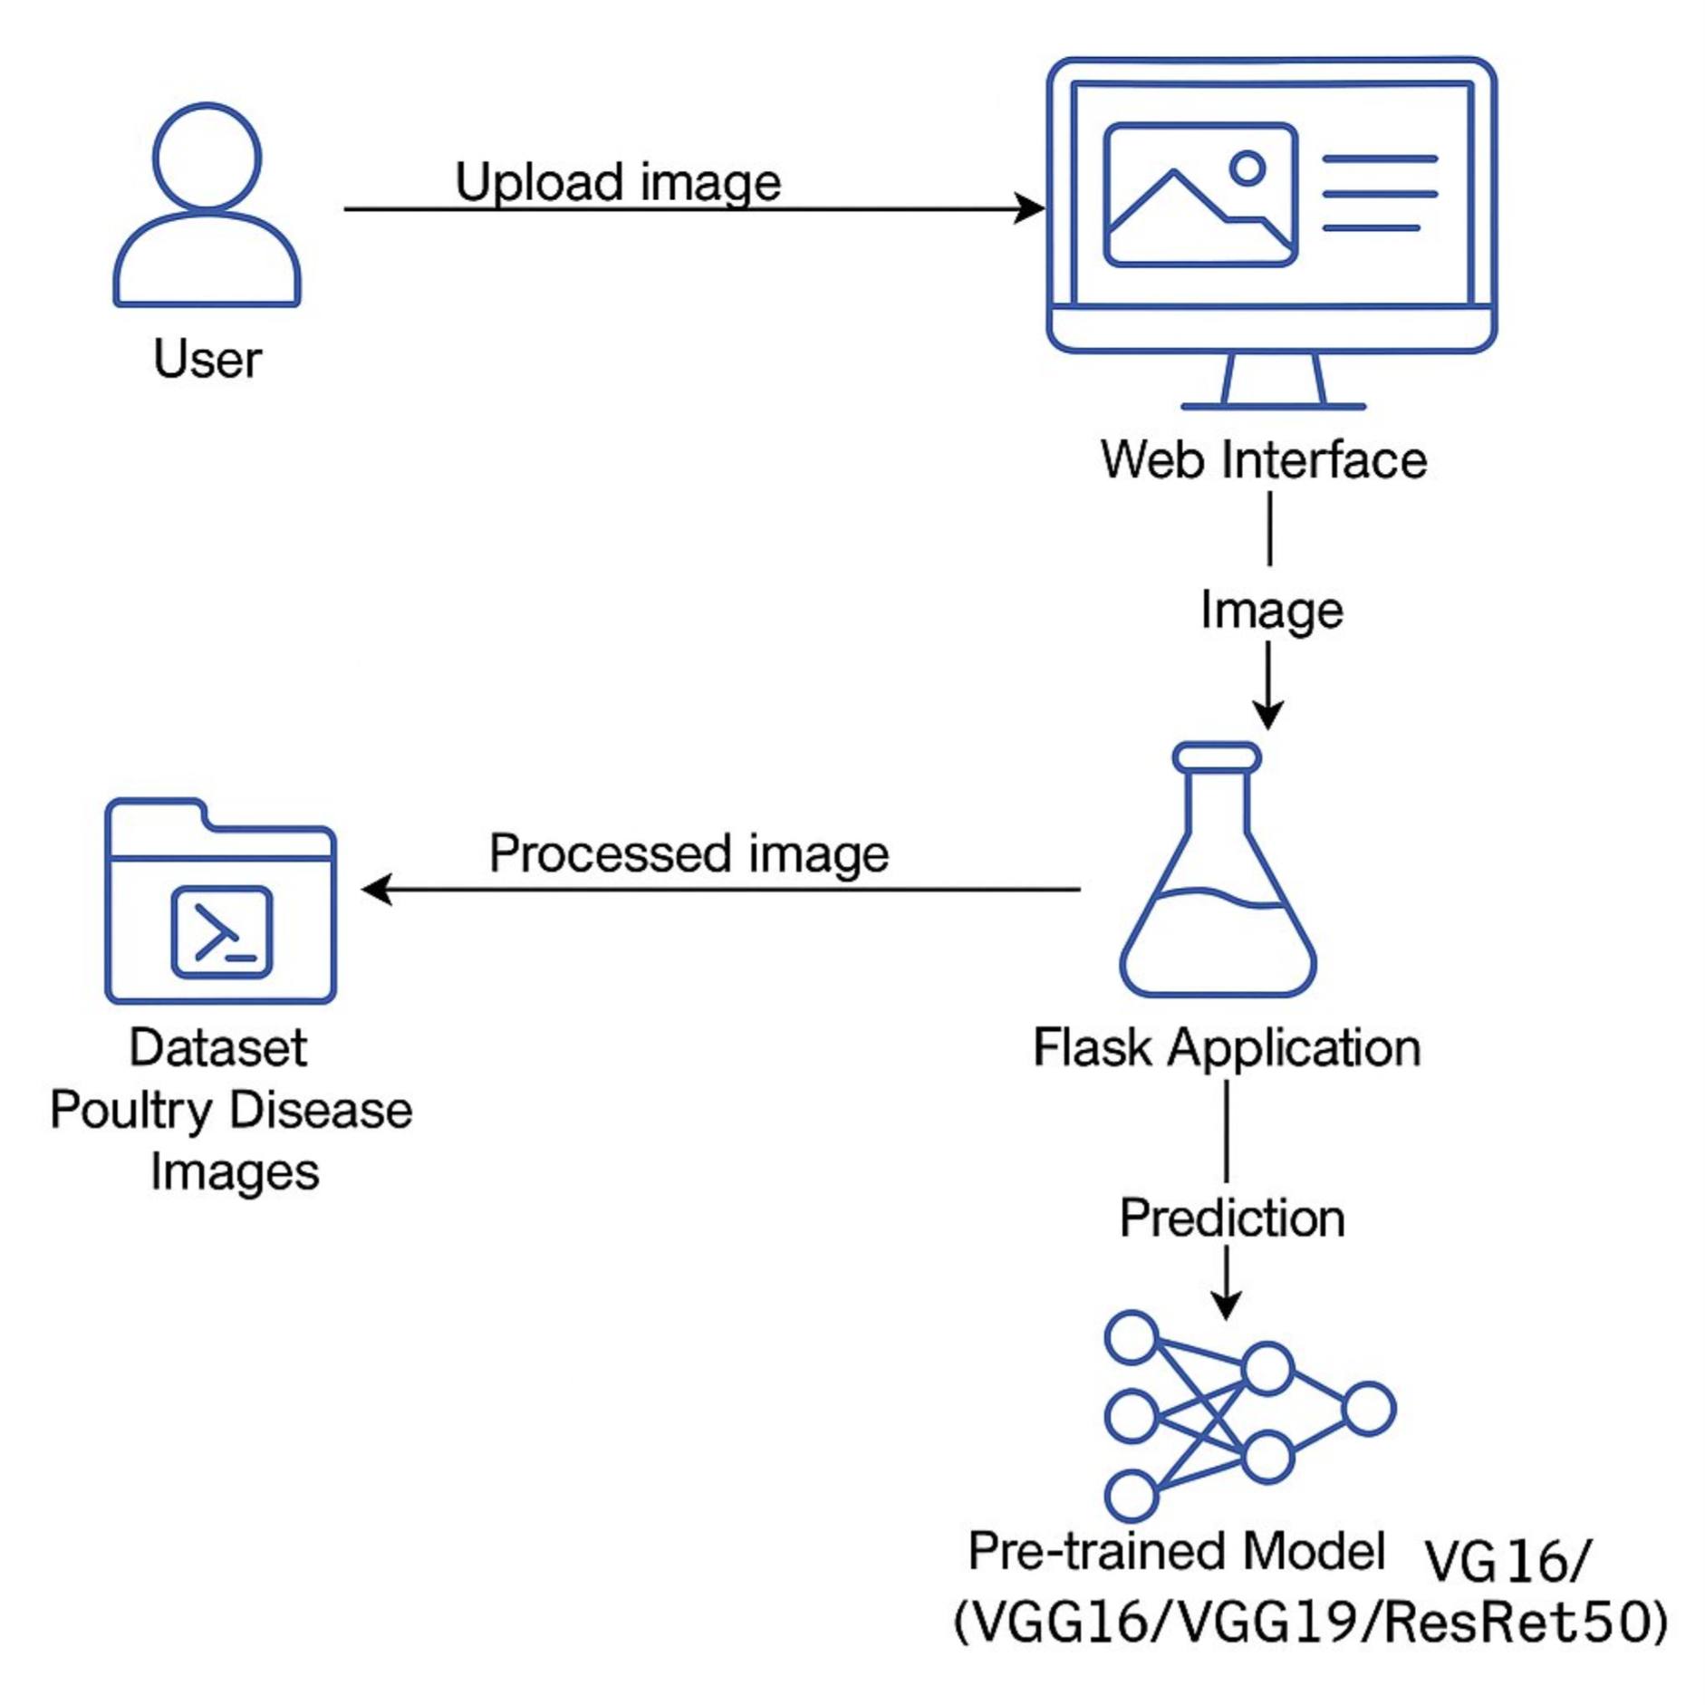

**Data Flow:**

1. User uploads poultry image
2. Web Interface (HTML/Flask) sends image to backend
3. Flask Application preprocesses the image
4. Trained Model (VGG16/VGG19/ResNet50) predicts the disease
5. Prediction Result is sent back to the Web Interface
6. Dataset is used only during training phase, not in real-time flow